COMPARING THE WHOLE BODY VIBRATION EXPOSURES ACROSS
THREE TRUCK SEATS

*Fangfang Wang^{1, 2}, Hugh Davies³, Bronson Du⁴, Peter W. Johnson^{1, 2}

¹ Department of Industrial and Systems Engineering, University of Washington
² Department of Environmental and Occupational Health Sciences,
University of Washington
³ School of Population and Public Health, University of British Columbia
⁴ School of Public Health and Health Systems, University of Waterloo

Introduction

Studies have shown that exposure to whole-body vibration (WBV) is associated with several adverse health outcomes including low-back pain and driver fatigue, that may contribute to vehicle-related accidents¹. In order to reduce WBV exposure and mitigate potential adverse health outcomes associated with vehicle-induced vibrations, trucks are increasingly fitted with higher quality vibration-damping seats.
The objective of this study was to evaluate the efficacy of three commercially-available air-suspension truck seats for reducing truck drivers’ exposures to WBV. This study may aid various stakeholders in decision making such as clinicians (preventing reoccurrence of injury), and seat manufacturers, trucking companies, and truck drivers.

Methods

Seventeen truck drivers with mean age 49.3 years (range 35-64) were recruited for this study. Three seats were evaluated and compared in this study, one seat was the trucking company’s existing seat (Seat 1 – National Premium; Commercial Vehicle Group; Columbus OH). The other two seats were serially installed and tested in the same truck (Seat 2 – Elite; Sears Seating; Davenport, IA and Seat 3 – 6860/875 NTS; Isringhausen; Detroit, MI). According to ISO 2631-1 standards, WBV exposures were collected from the seat and the floor of the trucks using tri-axial accelerometers (Model 356B40; PCB Piezotronics; Depew, NY) over the drivers’ 10-hour full shift. WBV exposures from the three seats were compared over the whole routes as well as distinguishing travel over two different road types: paved highways and unpaved roads.
To facilitate comparisons across seats, daily average weighed WBV exposures A(8) and the cumulative-impulsive Vibration Dose Value WBV exposures VDV(8) were collected from the truck floor and driver seat top. In addition, the Seat Effective Amplitude Transmissibility (SEAT) was calculated as the ratio of the seat-measured vibration divided by the floor-measured vibration, the SEAT value gives a measure of how much vibration the seat attenuates. Finally, the truck operation time to reach the ISO 2631-1 daily vibration action limits (DVAL) was derived.
Repeated measures analysis of variance (RANOVA) methods were used to determine whether there were differences in WBV exposures across the three seats.
Results

The z-axis A(8) and VDV(8) measures from Seat 1 were significantly higher than Seat 2 and Seat 3 over the whole route. As can be seen in Figure 1, there were significant differences across seats in the z-axis A(8) and VDV(8) measures on the highways, with Seat 1 subjecting the truck drivers to the greatest WBV exposures. In addition, WBV exposures from the unpaved road segments were significantly greater than the highway segments. All WBV exposures from the unpaved road were above DVALs with no differences in WBV exposures across the three seats. On the paved highways, SEAT values of Seat 2 and Seat 3 were significantly lower than Seat 1, indicating better attenuating performance of the floor transmitted WBV exposures (p = 0.007 for A(8), p = 0.036 for VDV(8)). No significant difference was found across the SEAT values on the unpaved roads.
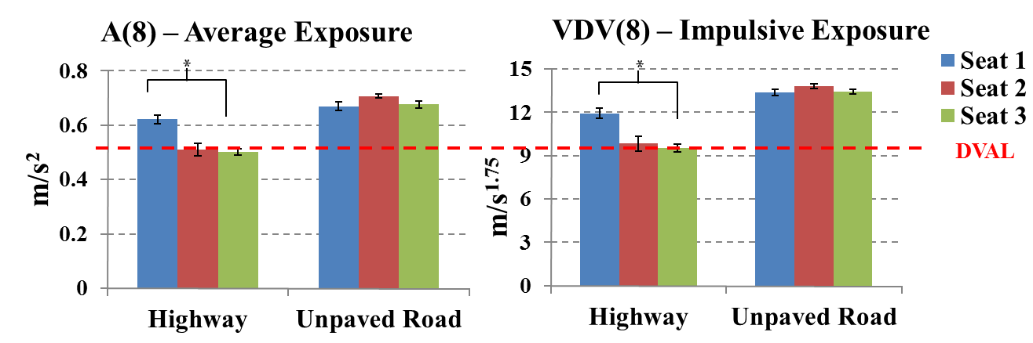
Figure 1. Mean (± SE) z-axis seat-measured A(8) and VDV(8) WBV exposures by road type.

Discussion

The results demonstrated that the WBV attenuation performance of the three seats differed and was dependent on road type. Similar to a previous study, in the higher-speed, on-road highway conditions, Seat 1 was found to have higher WBV exposures and lower WBV attenuation performance². In the off-road conditions at lower speed, there were negligible differences across the three seats.
These differences in seat performance have important practical implications. Based on the higher and more restrictive VDV(8) exposures, the higher performing seats can almost double the amount of time drivers could operate their trucks before reaching the ISO daily vibration action limits from 4 to 7 hours a day to 9 to 13 hours a day. Seat suspension-based design differences are thought to account for the performance differences. Our results indicate that there are at least two commercial air-suspension seats that can reduce truck drivers’ WBV exposures. These seats may ultimately reduce the potential for some vibration related musculoskeletal disorders among truck drivers.

References

1. Conway, G. E., Szalma, J. L. and Hancock, P. A. (2007). A quantitative meta-analytic examination of whole-body vibration effects on human performance. Ergonomics, 50(2), 228-245.
2. Kim J., Zigman M., Aulck L., Hughes M., Cavellari J., Dennerlein J. and Johnson P. (2015). Whole body vibration exposures in long-haul truck drivers. Proceedings of the Human Factors and Ergonomics Society Annual Meeting, 59(1), 1274–1278.

